Trigonometry:
Solving Word Problems

Trigonometry can be used on a daily basis in the workplace. Since trigonometry means "triangle measure", any profession that deals with measurement deals with trigonometry as well. Carpenters, construction workers and engineers, for example, must possess a thorough understanding of trigonometry.

In word problems, the formulas remain the same:

Word problems introduce two new vocabulary terms:
Angle of Elevation  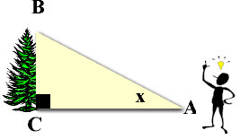 | The angle of elevation is always measured from the ground up. Think of it like an elevator that only goes up. It is always INSIDE the triangle.  In the diagram at the left, x marks the angle of elevation of the top of the tree as seen from a point on the ground.  You can think of the angle of elevation in relation to the movement of your eyes. You are looking straight ahead and you must raise (elevate) your eyes to see the top of the tree.
Angle of Depression  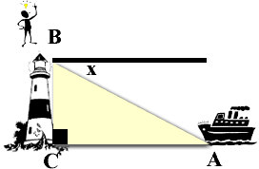 | The angle of depression is always OUTSIDEthe triangle. It is never inside the triangle.  In the diagram at the left, x marks the angle of depression of a boat at sea from the top of a lighthouse.  You can think of the angle of depression in relation to the movement of your eyes. You are standing at the top of the lighthouse and you are looking straight ahead. You must lower (depress) your eyes to see the boat in the water.
As seen in the diagram above of angle of depression, the dark black horizontal line is parallel to side CA of triangle ABC. This forms what are called alternate interior angles which are equal in measure
(so, x also equals the measure of <BAC).
Simply stated, this means that:
the angle of elevation = the angle of depression.

So what do we do with this angle of depression
that is OUTSIDE of our triangle?
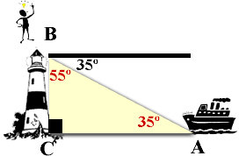 | There are two possible ways to use our angle of depression to obtain an angle INSIDE the triangle.  - find the angle adjacent (next door) to our angle which is inside the triangle. This adjacent angle will always be the complement of our angle. Our angle and the angle next door will add to 90º. In the diagram on the left, the adjacent angle is 55º.  - utilize the fact that the angle of depression = the angle of elevation and simply place 35º in angle A. (the easiest method) Just be sure to place it in the proper position.

