Triangles
A triangle has three sides and three angles
The three angles always add to 180°

Equilateral, Isosceles and Scalene
There are three special names given to triangles that tell how many sides (or angles) are equal.
There can be 3, 2 or no equal sides/angles:
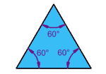 | Equilateral Triangle  Three equal sides  Three equal angles, always 60°
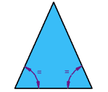 | Isosceles Triangle  Two equal sides  Two equal angles
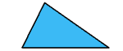 | Scalene Triangle  No equal sides  No equal angles

What Type of Angle?
Triangles can also have names that tell you what type of angle is inside:
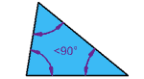 | Acute Triangle  All angles are less than 90°
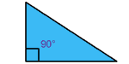 | Right Triangle  Has a right angle (90°)
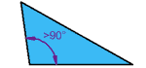 | Obtuse Triangle  Has an angle more than 90°

Combining the Names
Sometimes a triangle will have two names, for example:
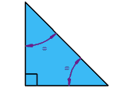 | Right Isosceles Triangle  Has a right angle (90°), and also two equal angles  Can you guess what the equal angles are?

