Translations

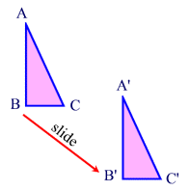 | A translation "slides" an object a fixed distance in a given direction. The original object and its translation have the same shape and size, and they face in the same direction. A translation creates a figure that is congruent with the original figure and preserves distance (length) and orientation (lettering order). A translation is a direct isometry.

Properties preserved (invariant) under a translation:
1. distance (lengths of segments are the same)
2. angle measures (remain the same)
3. parallelism (parallel lines remain parallel)
4. colinearity (points stay on the same lines)
5. midpoint (midpoints remain the same in each figure)
6. orientation (lettering order remains the same)
Definition: A translation (notation 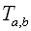) is a transformation of the plane that slides every point of a figure the same distance in the same direction.
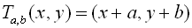

Translations in the Coordinate Plane:
In the example below, notice how each vertex moves the same distance
in the same direction.
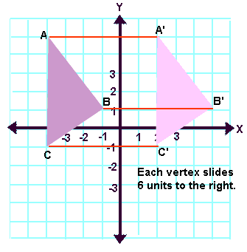
In this next example, the "slide" (translation) moves the figure
7 units to the left and 3 units down.
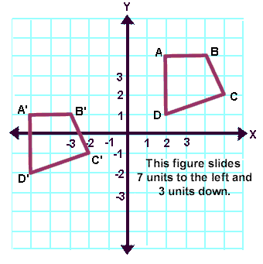

There are several ways to indicate that a translation is to occur:
1. | description: | 7 units to the left and 3 units down.  (A verbal description of the translation is given.)
2. | mapping: | (This is read: "the x and y coordinates will be translated into x-7 and y-3". Notice that adding a negative value (subtraction), moves the image left and/or down, while adding a positive value moves the image right and/or up.)
3. | notation: | 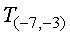  (The -7 tells you to subtract 7 from all of your x-coordinates, while the -3 tells you to subtract 3 from all of your y-coordinates.)  This may also be seen as T_{-7,-3}(x,y) = (x -7,y - 3).
4. | vectors: | 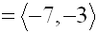  (A vector, a directed line segment, may also be used to show the movement of a translation. See more about vectors and translations.)

