The Distributive Law

Consider the expression a(b + c).
This expression represents the area of a rectangle of length b + c and width a. So, this expression can be represented as:
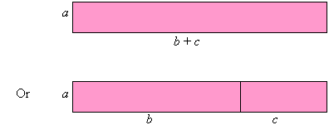
This can be split up into two parts as follows:
Now, the sum of the areas of the rectangles = ab + ac.
This suggests that:
This is called the Distributive Law.

Example 14
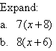

Solution:
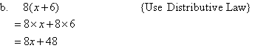

Example 15
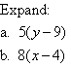

Solution:

Example 16
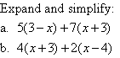

Solution:

