Similar Triangles

Objects, such as these two cats, that have the same shape, but
do not necessarily have the same size, are said to be "similar".
The cat on the right is an enlargement of the cat on the left. They are exactly the same shape, but they are NOT the same size.
These cats are similar figures.

The mathematical symbol used to denote  similar is .  Do you remember this symbol as "part" of the symbol for congruent?? | Similar  Symbol

Definition: In mathematics, polygons are similar if their corresponding (matching) angles are congruent (equal in measure) and the ratio of their corresponding sides are in proportion.
(This definition allows for congruent figures to also be "similar",
where the ratio of the corresponding sides is 1:1.)
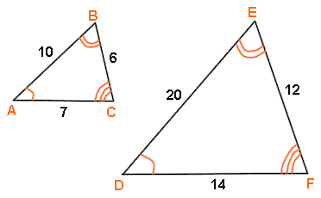
Facts about similar triangles: | The ratio of the corresponding sides is called the ratio of similitude or scale factor.

