Rotations

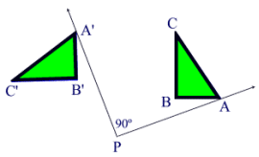 | A rotation is a transformation that turns a figure about a fixed point called the center of rotation. Rays drawn from the center of rotation to a point and its image form an angle called the angle of rotation.  (notation R_{degrees} )
An object and its rotation are the same shape and size, but the figures may be turned in different directions.
Properties preserved (invariant) under a rotation:
1. distance is preserved (lengths of segments are the same)
2. angle measures (remain the same)
3. parallelism (parallel lines remain parallel)
4. colinearity (points stay on the same lines)
5. midpoint (midpoints remain the same in each figure)
6. orientation (lettering order remains the same)
Definition: A rotation is an isometry where if P is a fixed point in the plane, is any angle and then 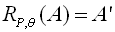 where and 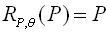.
So what is this definition saying:
Part I (up to the word "and"): Here we see an example where the angle is 90 degrees. The center of rotation is point P and point A is distinct from point P. In addition to point A, we also have points B and Cforming triangle ABC. | Part II (after the word "and"): The second part of the definition deals with point P beingrotated about itself. Rotating a POINTabout itself creates no noticeable changes. The image from this rotation will be the same pointP that you started with. This is represented by

A rotation turns a figure through an angle about a fixed point called the center.
When working in the coordinate plane, assume the center of rotation to be the origin unless told otherwise. A positive angle of rotation turns the figure counterclockwise, and a negative angle of rotation turns the figure in a clockwise direction.
Rotation of 90°:
Rotation of 180°: | (same as point reflection in origin)
Rotation of 270°:

