|  |
| --- |
| **Session 2** |

34. Each day, approximately 60 million plastic bottles are thrown away in the United States. On average, how many plastic bottles are thrown away in the United States ***per hour***?

***Show your work.***

***Answer\_\_\_\_\_\_\_\_\_\_\_\_\_\_\_\_\_\_\_\_\_\_\_\_\_***

**35. Julie sold 125 frozen juice bars and 150 ice cream cones on Saturday. She made a total of $500. Julie sold each ice cream cone for $2.25.**

**Part A**

**Write an equation you can use to find the cost, *c,* of each frozen juice bar.**

***Equation\_\_\_\_\_\_\_\_\_\_\_\_\_\_\_\_\_\_\_\_\_\_\_\_\_\_\_\_\_\_\_\_\_\_\_\_\_\_\_\_\_\_\_\_***

**Part B**

**Solve the equation you wrote to find the cost of one frozen juice bar.**

***Show your work.***

**Answer\_\_\_\_\_\_\_\_\_\_\_\_\_\_\_\_\_\_\_\_\_\_\_\_**

**EIGHTH-GRADE CLASS TRIP**

The eighth-grade class at Central Middle School took a day trip to a local city park for the annual "Eighth-Grade Recreation Day." You were the event coordinator in charge of managing the budget, transportation, activities, and meals. It was a full day of activities with events planned for the morning and afternoon and a lunch break in between.

|  |
| --- |
| Directions: Now do numbers 36 through 38 about the eighth grade class trip on the following pages. |
| 36. The class had a budget of $800 for the trip. They had reserved 55% of the money for food and beverages. The remainder of the money was used for transportation. If transportation costs $2.25 per person, how many students were able to participate?  ***Show your work.***          ***Maximum number of students\_\_\_\_\_\_\_\_\_\_\_\_\_\_\_\_\_\_\_\_*** |
| 37. One event was a basketball tournament. For the tournament, the students were divided into 5 teams: A, B, C, D, and E. Each team played each other team once. How many games were played in all?    ***Show your work.***        ***Answer\_\_\_\_\_\_\_\_\_\_***  m8_37pic.gif (26289 bytes) |

38. One afternoon event was a race through the park. The race started at the point with the coordinates of (2, 3). The first turn was at (2, 6). The second turn was at (6, 6), and the third turn was at (6, 8). The race ended at (12,8).

**Part A**

On the grid below, show the path of the race by plotting and connecting the points in the order given above. Label each of the points with the coordinates.

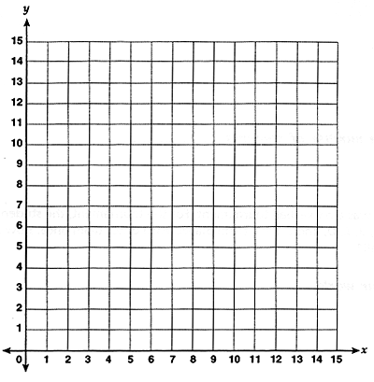

**Part B**

It was 120 yards from the starting point to the first turn of the race. How long, in yards, was the entire path of the race?

***Answer\_\_\_\_\_\_\_\_\_\_\_\_\_\_\_***

**Explain how you determined your answer.**

|  |
| --- |
|  |
|  |
|  |

39. Lucia’s mother has just opened a small business. The amounts of profit for each of the first 4 months the business was open are shown in the table below.

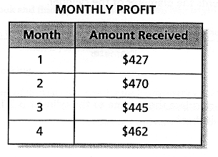

Lucia’s mother has a goal of making a total of $5,000 profit. If the amount of monthly profit continues to be about the same as in the first 4 months, estimate how many more months it will take until the business reaches the goal of $5,000 in profit.

***Show your work.***

***Answer\_\_\_\_\_\_\_\_\_\_\_\_\_\_\_\_\_\_\_\_\_\_\_\_\_\_\_\_***

40. This line segment represents the diameter of the cylinder.

m8_40.gif (2827 bytes)

**Part A**

If the value of  used to calculate the volume of the cylinder is 3.14, what are the radius and the height of the cylinder in inches?

***Show your work.***

***Radius\_\_\_\_\_\_\_\_\_\_\_\_\_\_\_\_\_\_\_\_***

***Height\_\_\_\_\_\_\_\_\_\_\_\_\_\_\_\_\_\_\_\_***

**Part B**

Explain in words how you determined the radius and the height of the cylinder.

|  |
| --- |
|  |
|  |
|  |

**41. Graph the following inequality on the number line below.**

**15  x < 22**

**m8_41.gif (5690 bytes)**

**42. Deanna had 48 jelly beans. She ate 3/8 of her jelly beans. Her brother, Nathan, ate 2/3 as many jelly beans as Deanna ate. How many jelly beans did Nathan eat?**

***Show your work.***

***Answer\_\_\_\_\_\_\_\_\_\_\_\_\_\_\_\_\_\_\_\_\_\_\_\_***

**43. Triangle ABC, shown below, is a right triangle.**

**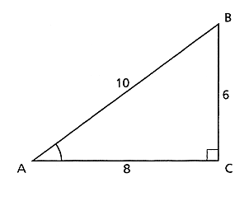**

**What are tthe numerical values of the cosine and tangent of angle A?**

***Cosine A\_\_\_\_\_\_\_\_\_\_\_\_\_\_\_\_\_\_\_\_\_\_\_***

***Tangent A\_\_\_\_\_\_\_\_\_\_\_\_\_\_\_\_\_\_\_\_\_***

**44. Using the table, fill in the missing numbers for the 4 ordered pairs for the function:**

**2x + y = 6**

**Part A**

**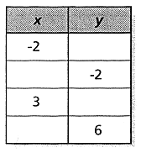**

**Part B**

**On the grid below, graph the function 2x + y = 6. Be sure to label the 4 points with the coordinates from the table.**

**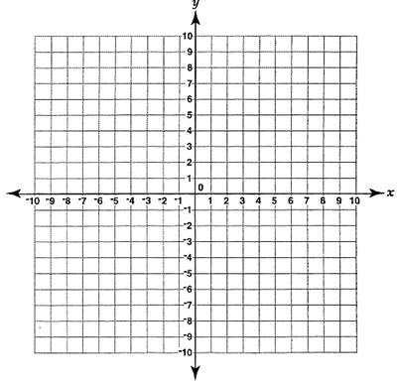**

**45. A shirt regularly sells for $22.50. It is on sale at the 15% discount. The sales tax is 8.5%.**

**Part A**

**What is the total price of the shirt on sale including tax?**

***Show your work*.**

***Answer\_\_\_\_\_\_\_\_\_\_\_\_\_\_\_\_\_\_\_\_***

**Part B**

**In determining the total price of the shirt, is there a difference between:**

* **Adding the sales tax before subtracting the discount?**

**AND**

* **Adding the sales tax after subtracting the discount?**

***Show your work and explain in words.***

|  |
| --- |
|  |
|  |
|  |