Part 2 | Session 1
28. In the inequality below, which of the following numbers could replace the variable X?
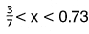
Circle all of the numbers below which would make the inequality true.
Explain in words why each number you circled could replace the variable X.

29. The variables a, b, c and d each represent a different whole number.
Given a = 3, use the properties of whole numbers to determine the value for each variable. For each variable, show the work you used to determine your answer.
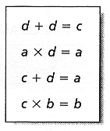
Show your work.

Answers
b = ___________
c = ___________
d = ___________

30. Students at a middle school volunteered to collect aluminum cans and plastic bottles in the local park as part of a community cleanup program. The table below shows the number of cans and plastic bottles the students collected during the first four weeks of the program.
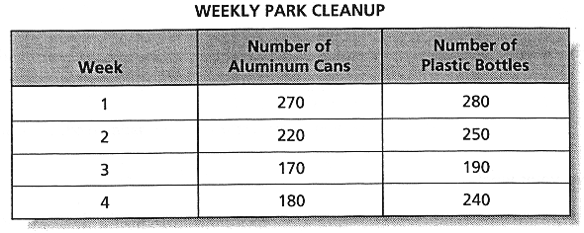

Part A
Using the information from the table, construct a double line graph on the grid below.
Be sure to:
  - Title your graph
  - Label the axes
  - Use appropriate and consistent scales
  - Accurately graph the data
  - Use an appropriate key
Part B

Use your double line graph to find the week when the difference between the number of aluminum cans collected and the number of plastic bottles collected was the greatest.

Week number_______________

31. Three quadrilaterals have the following coordinates:
Quadrilateral 1 coordinates: (-4, 9), (3, 9), 3, 5), (-4, 5)
Quadrilateral 2 coordinates: (-9, -4), (-4, -4), (-1, -7), (-12, -7)
Quadrilateral 3 coordinates: (6, -2), (10, -4), (10, -12), (6, -10)

Part A
On the grid below, plot the coordinates for each quadrilateral, connecting the points in order as you proceed. Be sure to connect the last point to the first point for each quadrilateral. Label the quadrilaterals 1, 2, and 3.
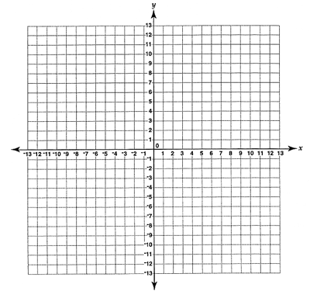
Part B
Match each numbered figure that you drew with the name or names that apply to each quadrilateral. Explain in words why it is this type of quadrilateral.

Parallelogram_______________________________________________________________

Rectangle___________________________________________________________________

Trapezoid___________________________________________________________________

32. For lunch, each student had a choice of one main course, one beverage, and one dessert from the menu below.
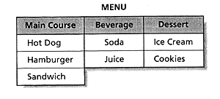
How many different combinations of lunches consisting of one main course, one beverage, and one dessert could a student choose?

Show your work.

Answer_______________________
A Student was given a randomly selected lunch consisting of a main course, a beverage, and a dessert, What is the probability that the lunch consisted of a main course, soda, and ice cream?

Probability_____________________

33. All the telephone poles in a certain area are 30 feet tall. The distance from the top of one telephone pole to the base of the next telephone pole is 50 feet.
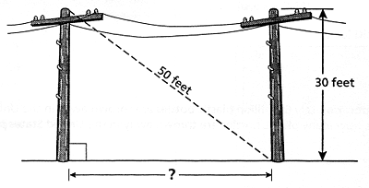
What is the number of feet between the two telephone poles?
Show your work or explain in words.

Answer__________________________
Use your browser's Back button to return and select another section of the test.

