Part 1 | Session I

1. To solve the following expression, which operation must you perform first?
8 + 12 (7 – 5) — 6
A | +
B | -
C | x
D | —

2. One way to find all the factors of 72 is to find its prime factorization. What is the prime factorization of 72?
F | 3³ x 2²
G | 6 x 3 x 2²
H | 3² x 2³
J | 4 x 2 x 3²

3. A measuring cup has lines marking the fractions of a cup. In what order should the lines on the cup be labeled, starting with the bottom line of the measuring cup?
A
B
C
D

4. What value of n will make the following statement true?
256 = 2^{n}
F | 6
G | 7
H | 8
J | 9

5. Frank and Joey ordered a large pizza. Frank ate 30% of the pizza and Joey ate 2/5 of the pizza. What percentage of the pizza did they eat in all?
A | 50%
B | 60%
C | 70%
D | 75%

6. A drawing of an isosceles trapezoid is shown below.
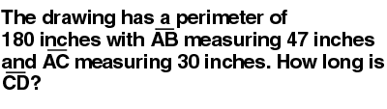
F | 47 inches
G | 60 inches
H | 73 inches
J | 103 inches

7. The school auditorium was full. What percent of the auditorium was full?
A | 7.8%
B | 37.5%
C | 62.5%
D | 87.5%
8. Use your ruler to help you solve this problem.
A garden is in the shape of a triangle as shown in the figure below. The garden is to be enclosed by a fence.
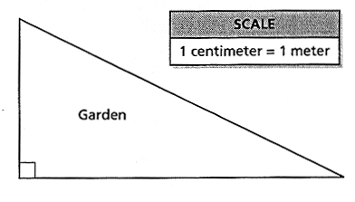
Based on the scale, how much fencing is needed to enclose the garden?
F | 19.1 meters
G | 20.7 meters
H | 23.5 meters
J | 26.6 meters

9. Look at the diagram below.
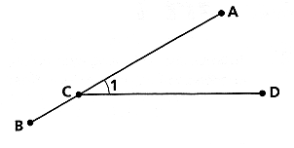
Which two segments intersect to form ?
A
B
C
D

10. Bob and Bill are fishing together.
Bob says to Bill, "If I catch this fish and 2 more, I will have a total of 3 fish."
Bill says to Bob, "Well, if I catch this fish and 3 more, I will have a total of 6 fish."
Which statement below is correct?
F | Bob has 1 fish
G | Bill has 2 fish
H | Bob has 3 fish
J | Bill has 6 fish

11. Wendy is taking a cab ride. The ride costs $1.20 for the first one-tenth of a mile, and $0.90 for each additional one-tenth of a mile. If the trip costs $12.00, how many miles was the cab ride?
A | 1 mile
B | 1.2 miles
C | 1.3 miles
D | 1.6 miles
12. A hotel is building a children’s wading pool in the shape of a square with a semicircle on one side. A diagram of the pool is shown below.
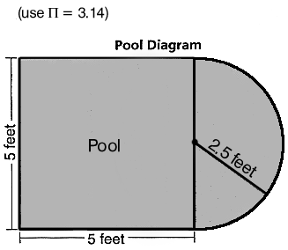
What is the perimeter of the children’s pool?
F | 22.85 feet
G | 27.85 feet
H | 40.70 feet
J | 45.70 feet

€
Directions
Do numbers 13 through 16 about Taylor’s Music Store.
13. Taylor’s Music Store will accept used compact disks (CDs) in exchange for new ones. Look at their exchange table below.
If the pattern continues and Maury has 22 CDs to exchange, what is the greatest number of new CDs he can get?
A | 7
B | 8
C | 9
D | 10

14. Taylor’s Music Store is open daily from 9:00 AM until 4:30 PM, 255 days a year. How many hours in all is the store open to the public each year?

F | 114.75 hours
G | 191.25 hours
H | 1147.5 hours
J | 1912.5 hours
15. Mr. Taylor recorded the number of sick days taken last year by each employee, as shown in the table below.
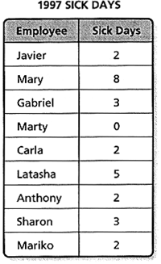
Which of the following represents the mean number of days employees were sick?
A | 3.00
B | 3.11
C | 3.38
D | 3.86
16. Once a week, Mr. Taylor selects one name out of a box to win a free CD. If there are 16 girls’ and 20 boys’ names in the box, what is the probability that a girl will be selected?
F | 4/9
G | 5/9
H | 4/5
J | 5/4

17. The figure below is right triangle ABC.
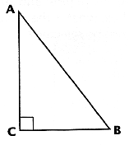
Which of these describes the relationship between angle A and angle B?
A | Angles A and B are complementary angles.
B | Angles A and B are right angles.
C | Angles A and B are supplementary angles.
D | Angles A and B are vertical angles.

18. In the equation below, which value for x will make this statement true?
3 (x-2) + 1 = 7
F | 0
G | 1
H | 4
J | 5
19. Which inequality is graphed correctly on the number line below?
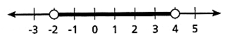
A
B
C
D
20. Sue is training for a 1-mile race. Every day she runs 1 mile and records her time. She recorded the following times last week:
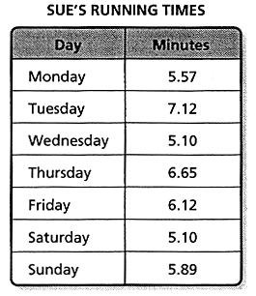
What is Sue’s median running time for the week?
F | 5.10
G | 5.89
H | 5.94
J | 6.65

21. A popular game at a carnival involves a spinner like the one shown below. The areas of sections 1, 3, 5, and 7 are equal. The area of section 9 is twice the area of any one of the other sections.
What is the probability that a player’s spin will be a 7?
A
B
C
D

22. The wingspan of a particular airplane is 41 feet. A scale model of the airplane is 1/10 of the plane’s actual size. Which proportion should be used to find the measure, w, of the model’s wingspan?
F
G
H
J

23. Which two figures are similar but not congruent?
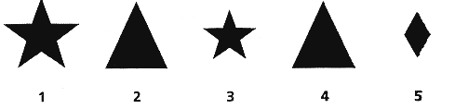
A | 3 and 5
B | 1 and 3
C | 2 and 4
D | 1 and 5

24. Every week Jake mows the lawn. Each time he mows, he cuts 1 inch off the top of the grass. If g equals the length of the grass before he mows, and m equals the length of the grass after he mows, which equation below would you use to find the length of the grass after Jake mows the lawn?
F | m – g = 1
G | m = 1 + g
H | m = g – 1
J | g = m – 1

25. Angela has a job finding golf balls at a golf course. She is paid $3.00 per hour and $0.25 for each golf ball she finds. If Angela finds an average of 15 golf balls per hour and she earns a total of $20.25 for one day’s work, how many hours has Angela worked?
A | 3 hours
B | 5.5 hours
C | 6 hours
D | 7 hours
26. Rachel has an envelope that contains only pennies, nickels, dimes, and quarters. There is more than $0.85 and less than $1.60 in the envelope. There is at least one penny, one nickel, one dime, and one quarter in the envelope.
Using the information above and the following clues, solve the problem:
- There are 3 times as many nickels as dimes.
- There are twice as many dimes as quarters.
- There is an equal number of pennies and quarters.
How much money is in the envelope?
F | $1.02
G | $1.22
H | $1.51
J | $1.52

27. One triangle is shown on the grid below. Two coordinates for a second triangle are also shown on the grid.
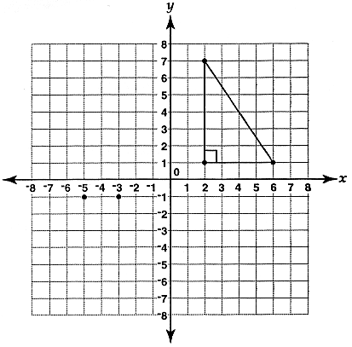
Which of the following sets of coordinates will create another triangle that is similar to the triangle that is shown?
A | (-3, -4)
B | (-3, 5)
C | (-3, -3)
D | (-3, 7

