Reference Table

Volume is measured in cubic units.
Surface area is measured in square units.
Volume (V) and Surface Area (SA) Formulas
Note: Surface area formulas may need to be amended if the figure has "open" surfaces,
such as when working with a box without a lid or with an empty paper towel roll.
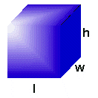 | Rectangular Solid  V=lwh  SA=2lh + 2hw + 2lw  This formula assumes a "closed box", with all 6 sides.
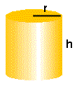 | Cylinder  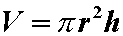  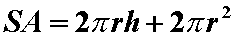  This formula assumes a "closed container", with a top and bottom..
(optional formula)  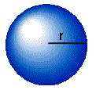 | Sphere  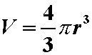  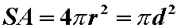
(optional formula)  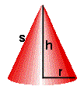 | Cone  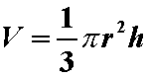  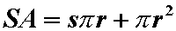  This formula assumes a "closed container", with a bottom..

