Pythagoras' Theorem
Years ago, a man named Pythagoras found an amazing fact about triangles:

If the triangle had a right angle (90°) ...
... and you made a square on each of the three sides, then ...
... the biggest square had the exact same area as the other two squares put together!

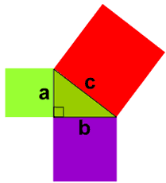 | It is called "Pythagoras' Theorem" and can be written in one short equation:  a² + b² = c²  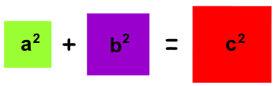  Note:  - c is the longest side of the triangle  - a and b are the other two sides

Definition
The longest side of the triangle is called the "hypotenuse", so the formal definition is:
In a right angled triangle:
the square of the hypotenuse is equal to
the sum of the squares of the other two sides.

Sure ... ?
Let's see if it really works using an example.

Example: A "3,4,5" triangle has a right angle in it.
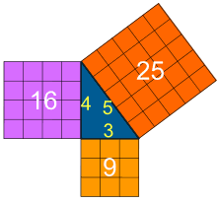 | Let's check if the areas are the same:  3² + 4² = 5²  Calculating this becomes:  9 + 16 = 25  It works ... like Magic!

Why Is This Useful?
If we know the lengths of two sides of a right angled triangle, we can find the length of the third side. (But remember it only works on right angled triangles!)

How Do I Use it?
Write it down as an equation:
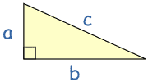 |  | a² + b² = c²
Now you can use algebra to find any missing value, as in the following examples:

Example: Solve this triangle.
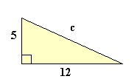 | a² + b² = c²  5² + 12² = c²  25 + 144 = c²  169 = c²  c² = 169  c = √169  c = 13
You can also read about Squares and Square Roots to find out why √169 = 13

Example: Solve this triangle.
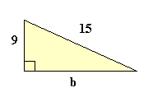 | a² + b² = c²  9² + b² = 15²  81 + b² = 225  Take 81 from both sides:  b² = 144  b = √144  b = 12

Example: What is the diagonal distance across a square of size 1?
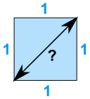 | a² + b² = c²  1² + 1² = c²  1 + 1 = c²  2 = c²  c² = 2  c = √2 = 1.4142...
It works the other way around, too: when the three sides of a triangle make a² + b² = c², then the triangle is right angled.

Example: Does this triangle have a Right Angle?
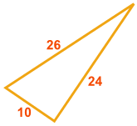 |  | Does a² + b² = c² ?  - a² + b² = 10² + 24² = 100 + 576 =676  - c² = 26² = 676  They are equal, so ...  Yes, it does have a Right Angle!

Example: Does an 8, 15, 16 triangle have a Right Angle?
Does 8² + 15² = 16² ?
- 8² + 15² = 64 + 225 = 289,
- but 16² = 256
So, NO, it does not have a Right Angle

Example: Does this triangle have a Right Angle?
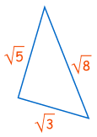 |  | Does a² + b² = c² ?  Does (√3)² + (√5)² = (√8)² ?  Does 3 + 5 = 8 ?  Yes, it does!  So this is a right-angled triangle

And You Can Prove The Theorem Yourself !
Get paper pen and scissors, then using the following animation as a guide:
- Draw a right angled triangle on the paper, leaving plenty of space.
- Draw a square along the hypotenuse (the longest side)
- Draw the same sized square on the other side of the hypotenuse
- Draw lines as shown on the animation, like this:
- Cut out the shapes
- Arrange them so that you can prove that the big square has the same area as the two squares on the other sides

Another, Amazingly Simple, Proof
Here is one of the oldest proofs that the square on the long side has the same area as the other squares.
Watch the animation, and pay attention when the triangles start sliding around.
You may want to watch the animation a few times to understand what is happening.
The purple triangle is the important one.

We also have a proof by adding up the areas.
Historical Note: while we call it Pythagoras' Theorem, it was also known by Indian, Greek, Chinese and Babylonian mathematicians well before he lived !

