Pyramids
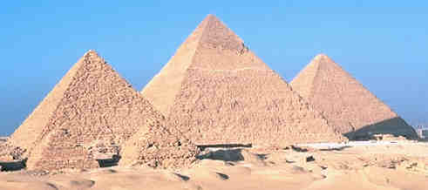
When we think of pyramids we think of the Great Pyramids of Egypt.  They are actually Square Pyramids, because their base is a Square. | 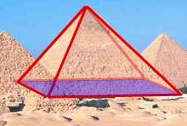

Parts of a Pyramid
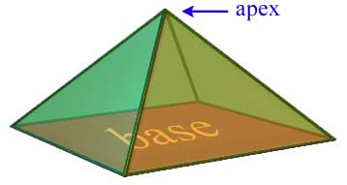
A pyramid is made by connecting a base to an apex

Types of Pyramids
There are many types of Pyramids, and they are named after the shape of their base.
 | Pyramid | Base
Triangular  Pyramid: | 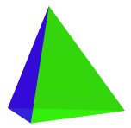 |  | Details >>
Square  Pyramid: | 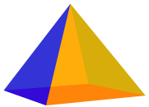 |  | Details >>
Pentagonal  Pyramid: | 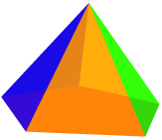 |  | Details >>
... and so on ...

Right vs Oblique Pyramid
This tells you where the top (apex) of the pyramid is. If the apex is directly above the center of the base, then it is a Right Pyramid, otherwise it is an Oblique Pyramid.
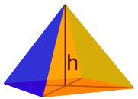 | 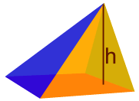
Right Pyramid | Oblique Pyramid

Regular vs Irregular Pyramid
This tells us about the shape of the base. If the base is a regular polygon, then it is a Regular Pyramid, otherwise it is an Irregular Pyramid.
Regular Pyramid | Irregular Pyramid
Base is Regular | Base is Irregular

Area and Volume
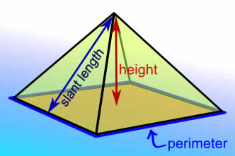 |  | The Volume of a Pyramid  - ¹/₃ × [Base Area] × Height  The Surface Area of a Pyramid  When all side faces are the same:  - [Base Area] + ¹/₂ × Perimeter × [Slant Length]  When side faces are different:  - [Base Area] + [Lateral Area]

Notes On Surface Area
The Surface Area has two parts: the area of the base (the Base Area), and the area of the side faces (the Lateral Area).
For Base Area :
It depends on the shape, there are different formulas for triangle, square, etc. See Area for formulas, or our Area Calculation Tool

For Lateral Area :
When all the side faces are the same:
- Just multiply the perimeter by the "slant length" and divide by 2. This is because the side faces are always triangles and the triangle formula is "base times height divided by 2"
But if the side faces are different (such as an "irregular" pyramid) then add up the area of each triangular shape to find the total lateral area.

