Pi (π)
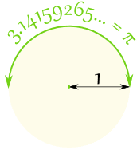 |  | Draw a circle with a radius of 1.  The distance half way around the edge of the circle  will be 3.14159265... a number known as Pi

Or you could draw a circle with a diameter of 1.  Then the circumference (the distance all the way  around the edge of the circle) will be Pi |  | 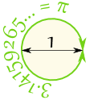

Pi (the symbol is the Greek letter π) is:
The ratio of the Circumference
to the Diameter
of a Circle.

In other words, if you measure the circumference, and then divide by the diameter of the circle you get the number π  It is approximately equal to:  3.14159265358979323846…  The digits go on and on with no pattern. In fact, π has been calculated to over two quadrillion decimal places and still there is no pattern. | 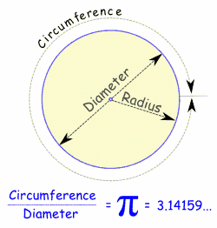

Example: You walk around a circle which has a diameter of 100m, how far have you walked?
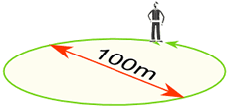 | Distance walked = Circumference = π × 100m = 314.159...m  = 314m (to the nearest m)

Approximation
A quick and easy approximation for π is 22/7
22/7 = 3.1428571...
But as you can see, 22/7 is not exactly right. In fact π is not equal to the ratio of any two numbers, which makes it an irrational number.
A better approximation (but stll not exact) is:
355/113 = 3.1415929...
(think "113355", then divide the "355" by the "113")

Remembering
I usually just remember "3.14159", but you can also count the letters of:
"May I have a large container of butter today"
3 1 4 1 5 9 2 6 5

To 100 Decimal Places
Here is π with the first 100 decimal places:
3.14159265358979323846264338327950288419716939937510 58209749445923078164062862089986280348253421170679...

