Perimeter
Perimeter is the distance around a two-dimensional shape.
Example 1: the perimeter of this rectangle is 7+3+7+3 = 20
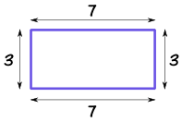
Example 2: the perimeter of this regular pentagon is 3+3+3+3+3 = 5×3 = 15
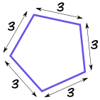

The perimeter of a circle is called the circumference:  Circumference = 2π × radius |  | 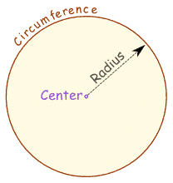

Perimeter Formulas
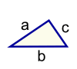 |  | Triangle  Perimeter = a + b + c
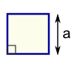 |  | Square  Perimter = 4 × a  a = length of side
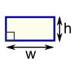 |  | Rectangle  Perimeter = 2 × (w + h)  w = width  h = height
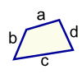 |  | Quadrilateral  Perimeter = a + b + c + d
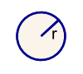 |  | Circle  Circumference = 2πr  r = radius
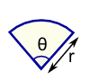 |  | Sector  Perimeter = r(θ+2)  r = radius  θ = angle in radians

