Percentages (%)

When you say "Percent" you are really saying "per 100"
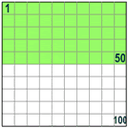 | So 50% means 50 per 100  (50% of this box is green) |  | And 25% means 25 per 100  (25% of this box is green) | 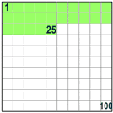

Examples:
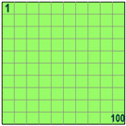 |  | 100% means all.  Example:  100% of 80 is ¹⁰⁰/₁₀₀ × 80 = 80
50% means half.
Example:
50% of 80 is ⁵⁰/₁₀₀ × 80 = 40
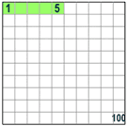 |  | 5% means ⁵/_{100ths}.  Example:  5% of 80 is ⁵/₁₀₀ × 80 = 4

Using Percent
Because "Percent" means "per 100" think:
"this should be divided by 100"
So 75% really means ⁷⁵/₁₀₀
And 100% is ¹⁰⁰/₁₀₀, or exactly 1 (100% of any number is just the number, unchanged)
And 200% is ²⁰⁰/₁₀₀, or exactly 2 (200% of any number is twice the number)

A Percent can also be expressed as a Decimal or a Fraction

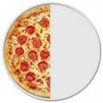 |  | A Half can be written...  As a percentage: 50%  As a decimal: 0.5  As a fraction: ¹/₂
Read more about this at Decimals, Fractions and Percentages.

Some Worked Examples

Example: Calculate 25% of 80
25% = ²⁵/₁₀₀
(²⁵/₁₀₀) × 80 = 20

So 25% of 80 is 20

Example: 15% of 200 apples were bad. How many apples were bad?
15% = ¹⁵/₁₀₀
(¹⁵/₁₀₀) × 200 = 15 × 2 = 30 apples
30 apples were bad

Example: if only 10 of the 200 apples were bad, what percent is that?
As a fraction, 10/200 = 0.05
As a percentage it is: (10/200) x 100 = 5%
5% of those apples were bad

Example: A Skateboard is reduced 25% in price in a sale. The old price was $120. Find the new price
First, find 25% of $120:
25% = ²⁵/₁₀₀
(²⁵/₁₀₀) × $120 = $30
25% of $120 is $30
So the reduction is $30

Take the reduction from the original price
$120 - $30 = $90
The Price of the Skateboard in the sale is $90

The Word
"Percent" comes from the latin Per Centum. The latin word Centum means 100, for example a Century is 100 years.

Percent vs Percentage
My Dictionary says "Percentage" is the "result obtained by multiplying a quantity by a percent". So 10 percent of 50 apples is 5 apples: the 5 apples is the percentage.
But in practice people use both words the same way.

