Parallel and Perpendicular Lines
How to use Algebra to find parallel and perpendicular lines.
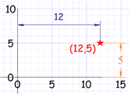 | Coordinates  We will be using Cartesian Coordinates, where we mark  a point on a graph by how far along and how far up it is.
Example: The point (12,5) is
12 units along, and 5 units up

You should also know about the equation of a line:  y = mx + b |  | 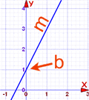

Parallel Lines
How do we know when two lines are parallel?
Their slopes are the same!

Example:  Find the equation of the line that is:  - parallel to y = 2x + 1  - and passes though the point (5,4) |  | 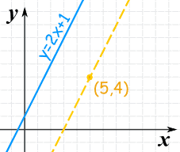
The slope of y=2x+1 is: 2
The parallel line must have the same slope!

Let us put that in the "point-slope" equation of a line:
y − y₁ = 2(x − x₁)
And now put in the point (5,4):
y − 4 = 2(x − 5)
And that is a good answer!

But let's also put it in the "slope-intercept (y = mx + b)" form:
y − 4 = 2x − 10
y = 2x − 6

Vertical Lines
But this does not work for vertical lines ... I explain why at the end.

Not The Same Line
Be careful! They may be the same line (just with a different equation), and so would not really be parallel.
How to know if they are really the same line? Check their y-intercepts (where they cross the y-axis):

Example: is y = 3x + 2 parallel to y − 2 = 3x ?
For y = 3x + 2: the slope is 3, and y-intercept is 2
For y − 2 = 3x: the slope is 3, and y-intercept is 2
In fact they are the same line and so are not parallel

Perpendicular Lines
Two lines are Perpendicular if they meet at a right angle (90°).
How do you know if two lines are perpendicular?
When you multiply their slopes, you get -1
This will show you what I mean:
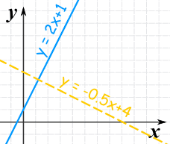 |  | These two lines are perpendicular:  Line Slope  y = 2x + 1 2  y = -0.5x + 4 -0.5  If we multiply the two slopes we get:  2 × (-0.5) = -1

Using It
OK, if we call the two slopes m₁ and m₂ then we could write:
m₁m₂ = −1
Which could also be:
m₁ = −1/m₂ | or | m₂ = −1/m₁
So, to go from a slope to its perpendicular:
- calculate 1/slope (the reciprocal)
- and then the negative of that
In other words the negative of the reciprocal.

Example:  Find the equation of the line that is  - perpendicular to y = −4x + 10  - and passes though the point (7,2) |  | 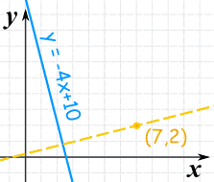
The slope of y=−4x+10 is: −4
The negative reciprocal of that slope is:
m = − | 1 | = | 1
 | −4 |  | 4
So the perpendicular line will have a slope of 1/4:
y − y₁ = (1/4)(x − x₁)
And now put in the point (7,2):
y − 2 = (1/4)(x − 7)
And that is a good answer!

But let's also put it in "y=mx+b" form:
y − 2 = x/4 − 7/4
y = x/4 + 1/4

Vertical Lines
The previous methods work nicely except for one particular case: a vertical line:
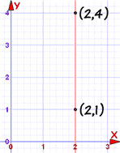 |  | In that case the gradient is undefined (because you cannot divide by 0):  m = y_{A} − y_{B} x_{A} − x_{B} = 4 − 1 2 − 2 = 3 0 = undefined
So just rely on the fact that:
- a vertical line is parallel to another vertical line.
- a vertical line is perpendicular to a horizontal line (and vice versa).

