Multiplication/Division
of Radicals

(For this lesson, the term "radical" will refer only to "square root".)
When multiplying radicals, you must multiply the numbers OUTSIDE (O) the radicalsAND then multiply the numbers INSIDE (I) the radicals.
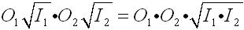
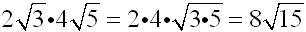
When dividing radicals, you must divide the numbers OUTSIDE (O) the radicals AND then divide the numbers INSIDE (I) the radicals.
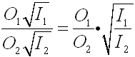 such as ... 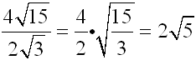
Should a radical appear in the denominator of a fraction, it will need to be "removed" if you are trying to simplify the expression.
To "remove" a radical from the denominator, multiply the top and bottom of the fraction
by that same radical to create a rational number (a perfect square radical) in the denominator.
This process is called rationalizing the denominator.
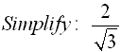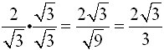

Example 1:
1. Multiply the outside numbers first | 2 • 3 = 6
2. Multiply the inside numbers
3. Put steps 1 and 2 together and simplify
4. Answer: | 72

Example 2:
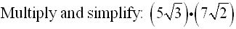
1. Multiply the outside numbers first | 5 • 7 = 35
2. Multiply the inside numbers
3. Put steps 1 and 2 together.
4. Answer:
Example 3:
1. Multiply the outside numbers first | 3 • 1 = 3
2. Multiply the inside numbers
3. Put steps 1 and 2 together and
simplify.
4. Answer:

Example 4:
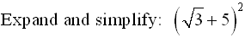
1. Remember that this expression is: | 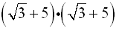
2. Multiply using distribution (or FOIL): | 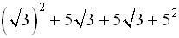
3. Simplify.
4. Answer:

Example 5:
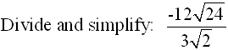
1. Divide the outside numbers first. | 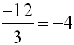
2. Divide the inside numbers. | 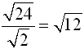
3. Put steps 1 and 2 together and simplify.
4. Answer:

Example 6:
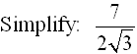
1. Multiply top and bottom by the radical. | 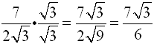
2. Answer: | 