A Summary of the Methods of Solving Quadratic Equations

Quadratic equations are of the form where a, b and c are real numbers and .
. Quadratic equations have two solutions. It is possible that one solution may repeat.
Solving by Factoring |  | Some quadratic equations can be solved by factoring. Set the equation equal to zero and factor.

Example 1:  Solve by factoring:  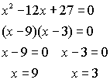 | Example 2:  Solve by factoring:  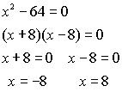 | Example 2:  Solve by factoring:  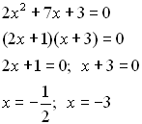

GRAPHING WILL NOT BE DONE IN WEEK 2
Solving by Graphing |  | Some quadratic equations can be solved by graphing. Setting the equation equal to zero will show the roots as locations on the x-axis.

Example 1: Solve by graphing:  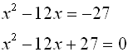  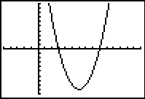 | Method 1: Set the equation equal to zero, if necessary. Find the roots using the ZERO command tool of the graphing calculator.
Example 2: Solve by graphing:  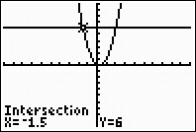 | Method 2: Graph each side of the equation separately. Use the INTERSECT command tool to find when the graphs cross. Repeat this process for both intersection points.  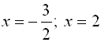

Solving by Quadratic Formula |  | Quadratic Formula:  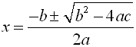
The solutions of some quadratic equations are not rational, and cannot be factored. For such equations, the most common method of solution is the quadratic formula. The quadratic formula can be used to solve ANY quadratic equation, even those that can be factored.
Be sure you know this formula!!!
Note: The equation must be set equal to zero before using the formula.
Example:  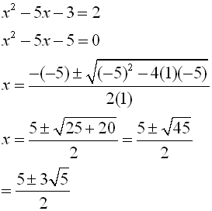 | 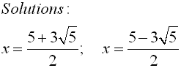  As decimal values:  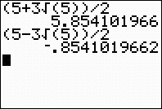

Solving by Competing the Square |  | Quadratic equations can be solved by completing the square.
Example:
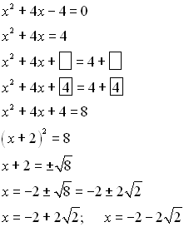 | Keep all terms containing x on one side. Move the constant to the right.  Get ready to create a perfect square on the left. Balance the equation.  Take half of the x-term coefficient and square it. Add this value to both sides.  Simplify and write the perfect square on the left.  Take the square root of both sides. Be sure to allow for both plus and minus.  Solve for x.

