Matrices
A Matrix is an array of numbers:
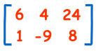
A Matrix
(This one has 2 Rows and 3 Columns)
We talk about one matrix, or several matrices.
There are many things we can do with them ...

Adding
To add two matrices: add the numbers in the matching positions:
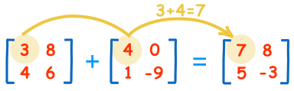
These are the calculations:
3+4=7 | 8+0=8
4+1=5 | 6-9=-3
The two matrices must be the same size, i.e. the rows must match in size, and the columns must match in size.
Example: a matrix with 3 rows and 5 columns can be added to another matrix of 3 rowsand 5 columns.
But it could not be added to a matrix with 3 rows and 4 columns (the columns don't match in size)

Negative
The negative of a matrix is also simple:
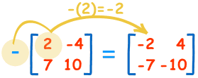
These are the calculations:
-(2)=-2 | -(-4)=+4
-(7)=-7 | -(10)=-10

Subtracting
To subtract two matrices: subtract the numbers in the matching positions:
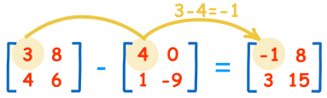
These are the calculations:
3-4=-1 | 8-0=8
4-1=3 | 6-(-9)=15
Note: subtracting is actually defined as the addition of a negative matrix: A + (-B)

Multiply by a Constant
We can multiply a matrix by some value:
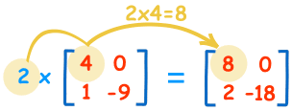
These are the calculations:
2×4=8 | 2×0=0
2×1=2 | 2×-9=-18
We call the constant a scalar, so officially this is called "scalar multiplication".

Multiplying by Another Matrix
To multiply two matrices together is a bit more difficult ... read Multiplying Matrices to learn how.

Dividing
And what about division? Well we don't actually divide matrices, we do it this way:
A/B = A × (1/B) = A × B⁻¹
where B⁻¹ means the "inverse" of B.
So we don't divide, instead we multiply by an inverse.
And there are special ways to find the Inverse ...
... learn more about the Inverse of a Matrix.

Transposing
To "transpose" a matrix, swap the rows and columns. We put a "T" in the top right-hand corner to mean transpose:
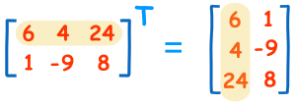

Notation
A matrix is usually shown by a capital letter (such as A, or B)
Each entry (or "element") is shown by a lower case letter with a "subscript" of row,column:
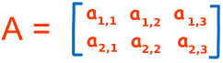

Rows and Columns
So which is the row and which is the column?
- Rows go left-right
- Columns go up-down
To remember that rows come before columns use the word "arc":
a_{r,c}

Example:
B =
Here are some sample entries:
b_{1,1} = 6 (the entry at row 1, column 1 is 6)
b_{1,3} = 24 (the entry at row 1, column 3 is 24)
b_{2,3} = 8 (the entry at row 2, column 3 is 8)

