LOCUS: Equidistant from Two Parallel Lines

Consider: During your morning jog, you run down an alley between two buildings which are parallel to one another and are 20 feet apart. Describe your path through the alley so that you are always the same distance from both buildings.

Answer:
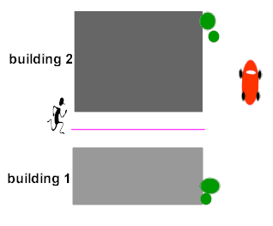
To maintain an equal distance from each building, you must jog in a straight line parallel to the buildings and halfway between them. In this problem, since the buildings are 20 feet apart, you will jog on a line 10 feet from each building.

Stated formally, we have our next locus theorem.

Locus Theorem 4: (parallel lines)
The locus of points equidistant from two parallel lines, l₁ and l₂ , is a line parallel to both l₁ and l₂ and midway between them.
