LOCUS: Equidistant from Two Points

Consider: You are playing a game of paint ball. Two of your friends are hiding behind trees that are 10 feet apart. Where could you possibly stand so that your firing distance to each friend is exactly the same length?

Answer:
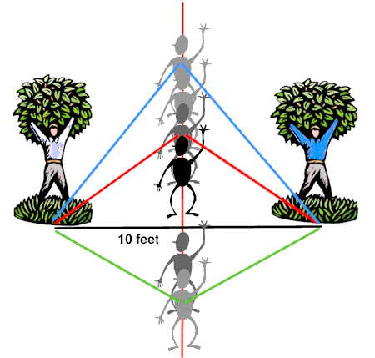
At first it may seem that there is only ONE spot to stand
where you are the same distance from both of your friends - that spot being directly between your friends, 5 feet from each friend.
But, as the diagram shows, there are actually many spots that will
position you exactly the same distance from both friends. Notice the formation of the isosceles triangles, where the congruent (equal) sides represent the distances to each friend.
The different positions where you might stand form the locus of points equidistant (equally distant) from your two friends. This line is the perpendicular bisector of the segment joining your two friends.

Stated formally, we have our next locus theorem.
Locus Theorem 3: (two points)
The locus of points equidistant from two points, P and Q, is the perpendicular bisector of the line segment determined by the two points.
