Locus: At a Fixed Distance
from a Line

Consider: Your teacher has placed a strip of tape on the classroom floor which forms a straight line. The teacher gives each student a yard stick and asks that each student stand exactly 3 feet away from the line on the floor. Can you picture what will happen? If you, and all of your classmates, stand exactly 3 feet away from the line, describe where you and your classmates will be standing.
Answer:
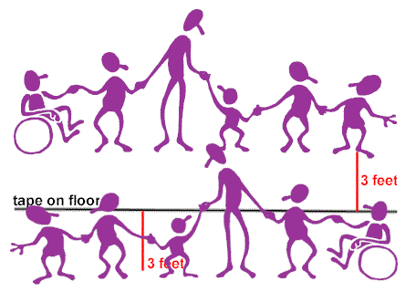
You and your classmates will form two straight lines on either side of the tape on the floor,
at a distance of 3 feet away from the tape.
You and your classmates are the locus of points equally distant (equidistant) from a given line (the tape on the floor).

Stated formally, we have our next locus theorem.
Locus Theorem 2: (line)
The locus of points at a fixed distance, d, from a line, l, is a pair of parallel lines d distance from l and on either side of l.
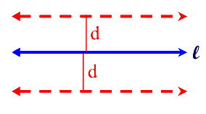

Note that all three of these lines are parallel.

