Locus: At a Fixed Distance from a Point

Consider: You are standing in the middle of your classroom. The teacher asks Mike, your classmate, to stand 5 feet away from you. The teacher then asks Carlos, Ashley and Anita to also stand 5 feet away from you. Can you start to picture what is happening? If all of your classmates were to stand 5 feet away from you, what geometric shape or path would your classmates be forming?
Answer: The students would be forming a circle around you. You are the center of the circle, and the radius of the circle would be a fixed distance of 5 feet.  The path where the students are standing is a locus.  The locus in this situation is a circle. | 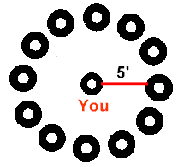
Stated formally, this path or shape becomes our first locus theorem:
Locus Theorem 1: (point)
The locus of points at a fixed distance, d, from point P is a circle with the given point P as its center and d as its radius.
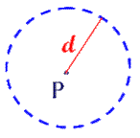

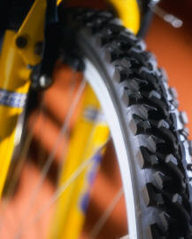 | Consider: Niko gets a stone wedged in the tire of his dirt bike. He lifts the bike and spins the wheel to look for the stone. Describe the path of the stone as Niko spins the wheel?  The stone is following a circular path around the center of the tire, illustrating our theorem.  Ponder:  If Niko "pushed" the bike along the ground to search for the stone, would the path of the stone still be a circle?
No. The path is no longer circular, as the wheel rolls forward. Remember we are following the path of the stone in each of its possible locations. The path would resemble:
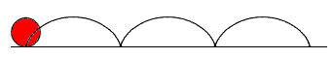
If you follow the path of a fixed point on a circle as it rolls on a line, it forms a curve called a cycloid.

Consider: When he is not in the house, Fido is tied to a stake in the backyard. His leash, attached to the stake, is 15 feet long. When traveling at the end of his leash, what is the locus of Fido's path?
Point P, from the theorem, is the stake to which Fido, the dog, is tied. His leash is 15 feet long. The path that Fido can travel at the end of his leash is "the locus of points".
The locus of points at a distance of 15 feet from point P is a circle (with center P and radius 15).

