Lines of Symmetry of Plane Shapes

Line of Symmetry
Here my dog "Flame" has her face made perfectly symmetrical with a bit of photo magic.
The white line down the center is theLine of Symmetry
Read more at Reflection Symmetry.

Folding Test
You can find if a shape has a Line of Symmetry by folding it.
When the folded part sits perfectly on top (all edges matching), then the fold line is a Line of Symmetry.
Here I have folded a rectangle one way, and it didn't work.
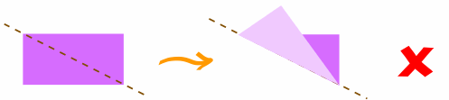
So this is not a Line of Symmetry
But when I try it this way, it does work (the folded part sits perfectly on top, all edges matching):
So this is a Line of Symmetry

Triangles
A Triangle can have 3, or 1 or no lines of symmetry:
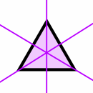 |  | 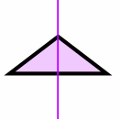 |  | 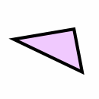
Equilateral Triangle  (all sides equal,  all angles equal) |  | Isosceles Triangle  (two sides equal,  two angles equal) |  | Scalene Triangle  (no sides equal,  no angles equal)
3 Lines of Symmetry |  | 1 Line of Symmetry |  | No Lines of Symmetry

Quadrilaterals
Different types of Quadrilaterals (a 4-sided plane shape):
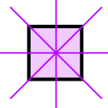 |  | 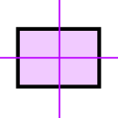 |  | 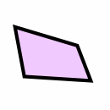
Square  (all sides equal,  all angles 90°) |  | Rectangle  (opposite sides equal,  all angles 90°) |  | Irregular  Quadrilateral
4 Lines of Symmetry |  | 2 Lines of Symmetry |  | No Lines of Symmetry

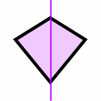 |  | 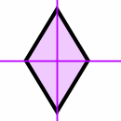
Kite |  | Rhombus  (all sides equal length)
1 Line of Symmetry |  | 2 Lines of Symmetry

Regular Polygons
A regular polygon has all sides equal, and all angles equal:
An Equilateral Triangle (3 sides)
has 3 Lines of Symmetry
A Square (4 sides)
has 4 Lines of Symmetry
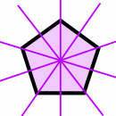 | A Regular Pentagon (5 sides)  has 5 Lines of Symmetry
 | 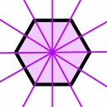 | A Regular Hexagon (6 sides)  has 6 Lines of Symmetry
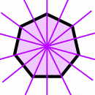 | A Regular Heptagon (7 sides)  has 7 Lines of Symmetry
 | 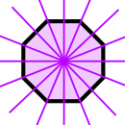 | A Regular Octagon (8 sides)  has 8 Lines of Symmetry
And the pattern continues:
- A regular polygon of 9 sides has 9 Lines of Symmetry
- A regular polygon of 10 sides has 10 Lines of Symmetry
- ...
- A regular polygon of "n" sides has "n" Lines of Symmetry

Circle  A line (drawn at any angle) that goes through its center is a Line of Symmetry.  So a Circle has infinite Lines of Symmetry. |  | 