Inverse Variation
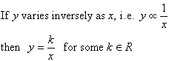
The constant k is called the constant of variation or the constant of proportionality.
Some practical examples of inverse variation are given below.
1. The pressure, P, of a given mass of a gas in a closed cylinder varies inversely as the volume, V, of the cylinder. That is:
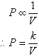
2. The current, I amps, produced by a battery is inversely proportional to the resistance, R ohms, of the circuit that the battery is connected to. That is:
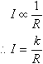

Example 14
If y varies inversely as x, and x = 3 when y = 4, find y when x = 8.

Solution:
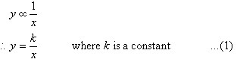
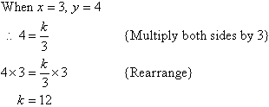
Substituting k = 12 in (1) gives:
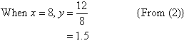

Note:
- Inverse variation exists if the value of one variable decreases as the value of the other variable increases.
For example, as the speed of the vehicle increases, the time taken to complete the journey decreases.
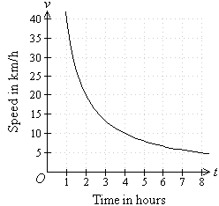
- Graphical representation of inverse variation takes the shape of a hyperbola, as shown above.

