Highest Common Factor of Algebraic Expressions

The highest common factor (HCF) of algebraic expressions is obtained in a similar way to the method used for numbers.

Example 23
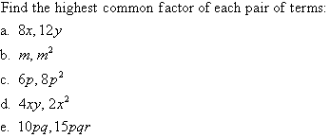

Solution:
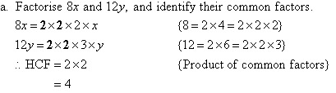
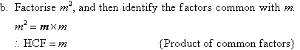
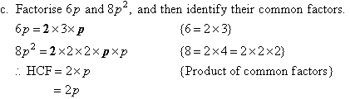
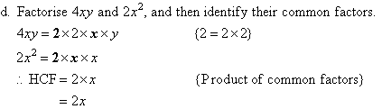
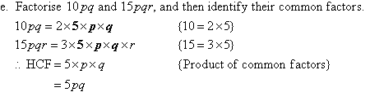

Example 24
Find the highest common factor of
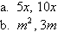

Solution:
