Factors by Grouping 'Two and Two'

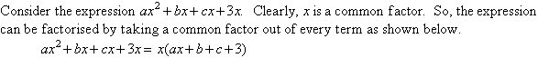
Now, consider the expression 7x + 14y + bx + 2by. Clearly, there is no factor common to every
term. However, it is clear that 7 is a common factor of the first two terms and b is a common factor
of the last two terms. So, the expression can be grouped into two pairs of two terms as shown.
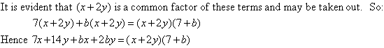
This factorisation technique is called grouping 'Two and Two'; and it is used to factorise an
expression consisting of four terms.

Example 8
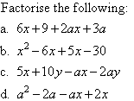

Solution:
