We know that:
a(b + c) = ab + ac
The reverse process, ab + ac = a(b + c), is called taking out the common factor.
Consider the factorisation of the expression 5x + 15.
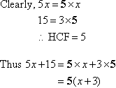
Note that the common factor 5 has been taken out and placed in front of the brackets. The expression inside the brackets is obtained by dividing each term by 5.

In general:
To factorise an algebraic expression, take out the highest common factor and place it in front of the brackets. Then the expression inside the brackets is obtained by dividing each term by the highest common factor.

Example 6
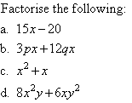

Solution:

Note:
The process of taking out a common factor is of great importance in algebra. With practice you will be able to find the highest common factor (HCF) readily and hence factorise the given expression.

Example 7
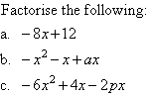

Solution:
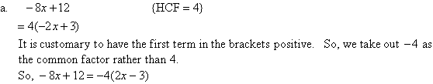

Note:
We can check the answer by using the Distributive Law.

