Constructions
Geometric Constructions ... Animated!
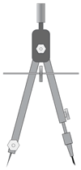 | "Construction" in Geometry means to draw shapes, angles or lines accurately.  These constructions use only compass, straightedge (i.e. ruler) and a pencil.  This is the "pure" form of geometric construction - no numbers involved! | 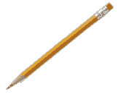
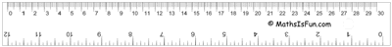

Learn these two first, they are used a lot:
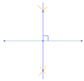 | Line Bisector
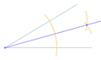 | Angle Bisector
And it is useful to know how to do 30°, 45° and 60° angles. You can use the angle bisector method (above) to create other angles, such as 15°, etc:
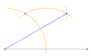 | 30 Degree Angle
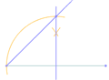 | 45 Degree Angle
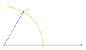 | 60 Degree Angle
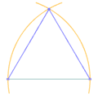 | Equilateral Triangle
Points and Lines:
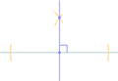 | Perpendicular to a Point on a Line
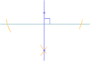 | Perpendicular to a Point NOT on a Line
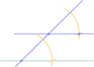 | Parallel Line through a Point
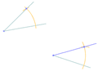 | Same (Congruent) Angle
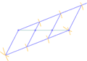 | Cut a line into N segments
Circles:
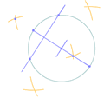 | Center of a Circle
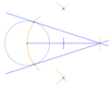 | Point to Tangents on a Circle
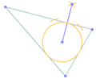 | Inscribe a Circle in a Triangle
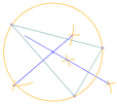 | Circumscribe a Circle on a Triangle
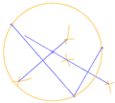 | Circle touching 3 Points
And for the "Master Class", a Pentagon
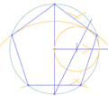 | Pentagon

