Area of Triangle and Parallelogram Using Trigonometry

We are all familiar with the formula for the area of a triangle, ,  where b stands for the base and h stands for the height drawn to that base. | 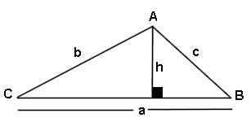  (the lettering used is of no importance)
In the triangle at the right, the area could be expressed as: 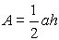
Now, let's be a bit more creative and look at the diagram again. By using the right triangle on the left side of the diagram, and our knowledge of trigonometry, we can state that:
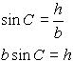
This tells us that the height, h, can be expressed as bsinC.
If we substitute this new expression for the height, we can write the triangle area formula as:  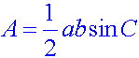  (where a and b are adjacent sides and C is the included angle) | 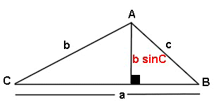
We have just discovered that the area of a triangle can be expressed using the lengths of two sides and the sine of the included angle. This is often referred to as the SAS Formula for the area of a triangle.
The "letters" in the formula may change from problem to problem, so try to remember the pattern of "two sides and the sine of the included angle".
"Wow! A trig area formula for triangles!!!" | We no longer have to rely on a problem supplying us with the length of the altitude (height) of the triangle in order for us to find the area of the triangle. If we know two sides and the included angle, we are in business.

Example 1:
Given the triangle at the right, find its area. Express the area rounded to three decimal places.  Be careful!!! When using your graphing calculator, be sure that you are in DEGREE Mode, or that you are using the degree symbol. | 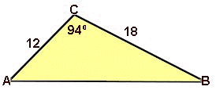

Example 2:
Given the parallelogram shown at the right, find its EXACT area.  If we are looking for an EXACT answer, we do NOT want to round our value for sin 60º. We need to remember that the sin 60º  (from our 30º- 60º- 90º reference triangle)  is .  Now, the diagonal of a parallelogram divides the parallelogram into two congruent triangles. So the total area of the parallelogram will be doublethe area of one of the triangles formed by a diagonal.  square units. | 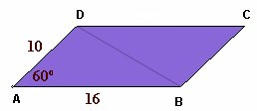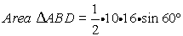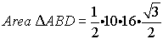

In Example 2, we discovered, due to the doubling, that the area of a parallelogram is really just
Parallelogram
(where a and b are adjacent sides and C is the included angle)

